Bank On Integrity
E-newsletter of the ICAC Corruption Prevention Network for Banks

February 2021

With the proliferation of bancassurance business, many bank staff are also licensed insurance intermediaries who actively promote wide array of insurance products provided by the banks to bank clients. In face of the keen competition, integrity is undoubtedly the key to business growth.

This issue of Bank on Integrity features a corruption case relating to insurance sales and introduces the ETHICS-PLUS decision-making model that helps bank staff resolve their ethical dilemmas at work.

Corruption case
Bribery over sales of insurance by bank staff

A relationship manager of a bank was responsible for promoting insurance products provided by the bank to clients.

To help her friend who was an insurance broker to meet his sales target, the relationship manager promoted an insurance product not provided by the bank to a bank client in her office and had the client signed the application form.

The insurance broker then signed on the form, falsely represented that he was the handling financial consultant and had met the client to explain the policy.

Upon approval of the application, the insurance company released commission of over $1.2M to the insurance broker. The relationship manager later accepted $0.5M from the insurance broker for the referral of client.

The relationship manager was sentenced to 18 months’ imprisonment for accepting the bribe and the insurance broker was put behind bars for eight months for fraud.

iSIR Notebook
- It is an offence under section 9 of the Prevention of Bribery Ordinance (POBO) (Cap 201) for an agent to accept any advantage as an inducement to, or reward for, his doing or forbearing to do any act, in relation to his principal’s affairs.
- The relationship manager was an agent of the bank. Whereas the bank, being her principal, did not allow the relationship manager to accept advantages in relation to her work duties.
- The relationship manager was subsequently found guilty of accepting the $0.5M bribe for referring a client to take out an insurance policy, violating Section 9(1) of POBO.
- The insurance broker, who submitted the insurance application containing false information to the insurance company, was also convicted for fraud, contrary to Section 16A of the Theft Ordinance.

iSIR’s Observation
- The judge commented that the relationship manager’s offence constituted a serious breach of trust placed on her by the bank. The broker’s act had also hampered the insurance industry, thus warranting a deterrent sentence.
- Insurance intermediaries may have immense pressure for meeting sales targets due to keen competition and the commission-based pay structure in the industry. The broker in the above case was desperate to meet his sales targets. Knowing his friend possessed an extensive client base, he even went as far as enticing her to refer potential customers to him. The lucrative offer, complicated with her personal relationship with the broker, had definitely put the relationship manager in an ethical quandary.
- To avoid losing sight in ethical dilemmas, it is important to uphold professional ethics and adhere to personal and corporate ethical standards when making decisions at work.

Ethical Decision Making
The ETHICS-PLUS Model is an ethical decision making tool developed by the Hong Kong Business Ethics Development Centre (HKBEDC) to help business practitioners resolve ethical dilemmas at work.

It consists of a six-step ETHICS thinking process guiding you to a righteous decision by applying the following PLUS standards:
- Professional / trade-related /company code of conduct
- Legal requirements
- Uncompromising self-values
- Sunshine tests

Stranded in an ethical crossroad? The Model is your guide. Click here to know how the Model operates through a case study concerning a bank manager!

HKBEDC – Your Integrity Protector
To maintain the high ethical standard of insurance practitioners, HKBEDC has recently launched the “Integrity for Success” Ethics Promotion Campaign for the Insurance Industry in collaboration with the Insurance Authority and 12 industry organisations. Under the Campaign, a series of training and publicity activities including an Ethics Promotion Website for the Insurance Industry, an online learning course for new practitioners and new Continuing Professional Development (CPD) courses for licensed intermediaries have been developed. We have also launched an online CPD module on anti-corruption laws and professional ethics in collaboration with the Hong Kong Federation of Insurers. Learners can earn 0.5 CPD hour on "Ethics and Regulations" after completing the module. Click here for details and enrolment.

To tie in with the 25th anniversary of the HKBEDC in 2020, we have revamped the Centre’s website with enriched content for different industries, among which a dedicated page on banking and finance has also been developed. We have also set foot in the LinkedIn to expand our connection and disseminate useful information to the business community.

Do subscribe to our e-news and follow our LinkedIn page for our latest training resources, news and activities.
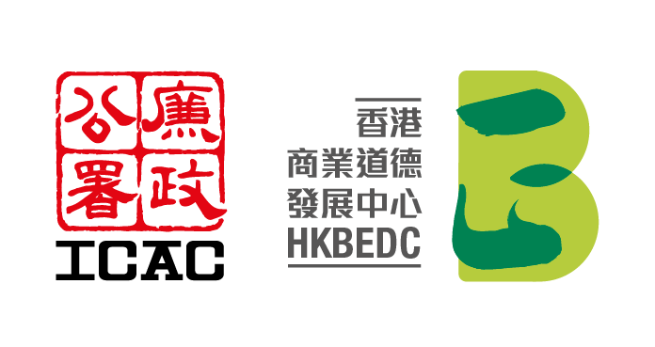
Hong Kong Business Ethics Development Centre
Service Hotline: (852) 2826 3288
(Mon – Fri, 9am – 6pm, except public holidays)
E-mail: hkbedc@crd.icac.org.hk

* * *

